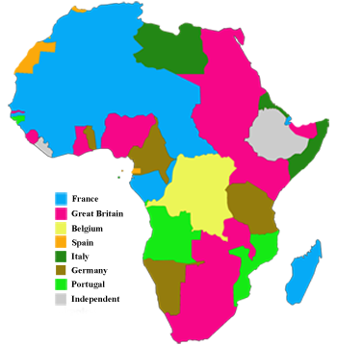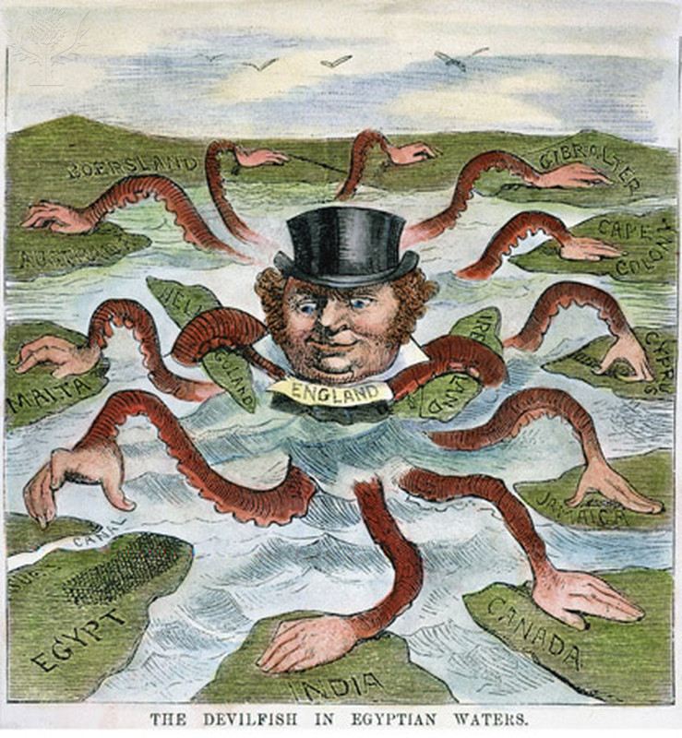

This 1882 American political cartoon, titles “The Devilfish in Egyptian Waters,” depicts England as an octopus. Notice that Egypt is not yet one of the areas controlled by the British.

At the Berlin Conference, in 1884-1885, Europeans established rules for dividing Africa with little concern about how their actions would affect the African people.

Economics

Industrialization increased the need for raw materials and new markets. Western imperialists were driven by this need as they looked for colonies to acquire.

#### THE DEVILFISH IN EDYPTIAN WATERS

Europeans exert influence over the economic, political, and social lives of the people they colonize.

**Cause**

1. Nationalism – To gain power, European nations compete for colonies and trade.
2. Economic Competition – Demand for raw materials and new markets spurs a search for colonies.
3. Missionary Spirit – Europeans believe they must spread their Christian teachings to the world.  
     
   **Effect**
4. Colonization – Europeans control land and people in areas of Africa, Asia, and Latin America.
5. Colonial Economics – Europeans control trade in the colonies and set up dependent cash-crops economics.
6. Christianization – Christianity spreads to Africa, India, and Asia.

# Imperialism

The Age

of

Imperialism

## Main Ideas

In the 19th & 20th century, western Powers divided Africa and colonized large areas of Asia.

Power and Authority

Empire Building

Chapter 11

1850-1914

Study Guide

World History

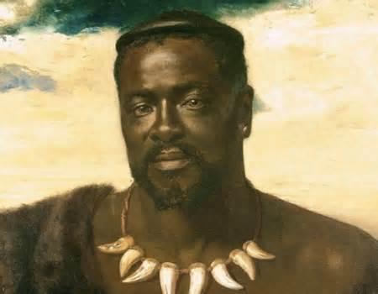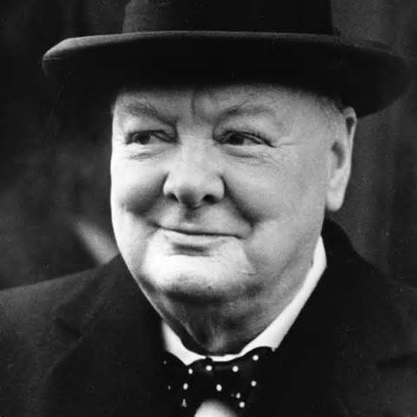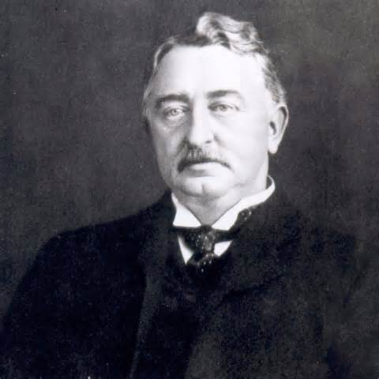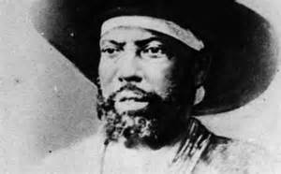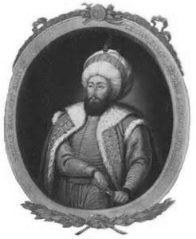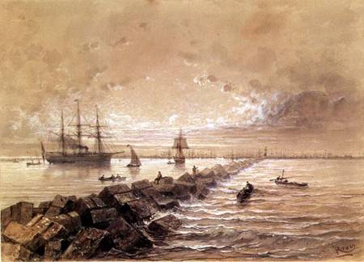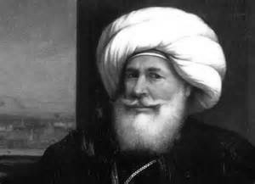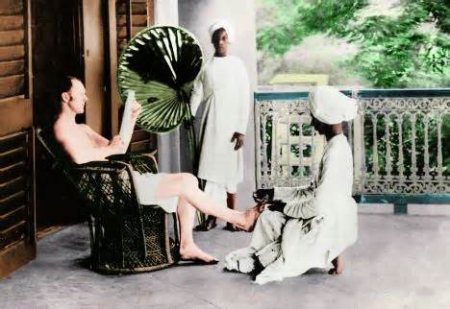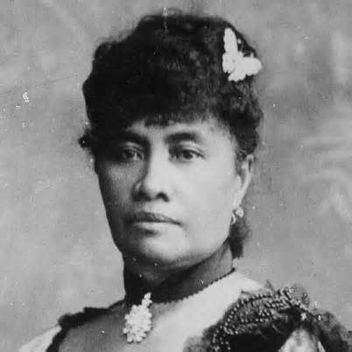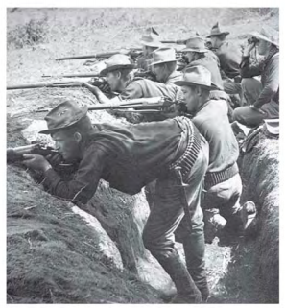

Imperialism -the seizure of a country or territory by a stronger country

Racism -the belief in which one race is superior than another

Social Darwinism -a social theory in which ideas about evolution and natural selection were applied to human society

Berlin Conference -a meet in which fourteen European nations laid down rules for the division of Africa in 1884-1885

Shaka -a Zulu chief in 1816 that used highly disciplined warriors and good military organization to create a large centralized state

Boers -Dutch settlers that gradually took African land and established large farms (also known as Afrikaners)

Boer War -a war between the British and Boers that became the first modern “total” war

Picture Information

Top Left: Rhoder’s De Beers Consolidated Mines is the biggest diamond company in the world today.

Top Center: Reinstated as ruler over part of his former nation, King Cetshwayo was soon driven away and died in exile in 1884.

Top Right: Winston Churchill first came to public attention during the Boer War. After his escape from the South African prison and returned to Britain, he became a national hero at the age of 26.

Industrialization stirred ambitions in many European nations. They wanted more resources to fuel their industrial production. They competed for new markets for their goods. Many nations looked to Africa as a source of raw materials and as a market for industrial products. As a result, colonial powers seized vast areas of Africa during the 19th and early 20th centuries. This seizure of a country or territory by a stronger country is called imperialism. As occurred throughout most of Africa, stronger countries dominated the political, economic, and social life of the weaker countries.

## Section 1 Vocabulary

### Ignoring the claims of African ethnic groups, kingdoms, and city-states, Europeans established colonies.

# The Scramble for Africa



Vocabulary

##### Europeans embarked on a new phase of empire building that affected both Africa and the rest of the world.

After defeating Italy, Menelik II modernized Ethiopia by constructing a railroad and weakening the power of the nobility.

Section 2

The Berlin Conference of 188401885 was a European conference. And, although black South Africans participated in it, the Boer War was largely a European war Europeans argued and fought among themselves over the land of Africa. In carving up the continent, the European countries paid little or no attention to historical political divisions or to the many ethnic and language groupings in Africa. Uppermost in the minds of the Europeans was the ability to control Africa’s land, its people, and its resources.

Paternalism

The actions in which a nation govern people in a paternal way by providing for their needs but not giving them their rights.

Assimilation

A policy in which the local populations would adopt French culture and become like the French.

Menelik II

This man ruled Ethiopia, the only African nation that successfully resisted the Europeans, after becoming emperor in 1889.

# Imperialism

# Case Study:

# Nigeria

Crimean War

A war between the Russians and the Ottomans in 1853 fought in a peninsula in the Black Sea where most was fought. Britain and France joined the side of the Ottoman Empire in hopes to prevent the oceans from gaining more Ottoman land.

Geopolitics

An interest in or taking of land for its strategic location or products played an important role in the fate of the Ottoman Empire.

Suez Canal

A canal that was a human-made waterway that cut through the Isthmus of Suez, which connected the Red Sea to the Mediterranean Sea.

# Europeans Claim Muslim Lands

### European nations expanded their empires by seizing territories from Muslim states.

Picture Information

Top Left: Muhammad Ali was a common soldier who rose to leadership as a result of his military skill and political shrewdness.

Top Center: The Suez Canal was viewed as the “Lifeline of the Empire” because it allowed Britain quicker access to its colonies in Asia and Africa. The painting represents the opening celebration of the canal on November 17, 1869.

Top Right: Nasir al-Din was killed by one of al-Afghani’s followers a few years after the boycott.

The European powers that carved up Africa also looked elsewhere for other lands to control. The Muslim land that rimmed the Mediterranean Sea had largely been claimed as a result of Arab and Ottoman conquests. As you have already learned before, the Ottoman Empire at its peak stretched from Hungary in the north, around the Black Sea, and across Egypt all the way west to the borders of Morocco. But during the empire’s last three hundred years, it had steadily declined in power. Europeans competed with tithers to gain control of this strategically important area.

## Section 3 Vocabulary



Class System in India:

A British officer being waited on by Indian servants.

British Army

Social class determined the way of life for the British Army in India. Upper-class men served as officers. Lower-class British served at lesser rank and did not advance past the rank of sergeant. Only men with the rank of sergeant and above were allowed to bring their wives to India.

Each English officer’s wife attempted to re-create England in the home setting. Like a general, she directed an army of 20-30 servants.

Indian Servants

Caste determined Indian occupations. Castes were divided into four broad categories called varna. Indian civil servants were of the third varna. House and personal servants were the fourth varna.

Even within the varna, jobs were strictly regulated, which is why such large servant staffs were required. For example, even if two servants were from the same varna, they had two different jobs.

#### **Social Class in India**

Section 4 Vocabulary

British economic interest in India began in the 1600s, when the British East India Company set up trading posts at Bombay, Madras, and Calcutta. At first, India’s ruling Mughal Dynasty kept European traders under control. By 1707, however, the Mughal Empire was collapsing. Dozens of small states, each headed by a ruler or maharajah, broke away from Mughal control. In 1757, Robert Clive led East India Company troops in a decisive victory over Indian forces allied with the French at the Battle of Plassey. From that time until 1858, the East India Company was the leading power in India.

Sepoys

-known as Indian solders who serve under British command

“Jewel in the Crown”

-due to 300 million people, India became the most valuable of all of Britain’s colonies

Sepoy Mutiny

-an 1857 rebellion of Hindu and Muslim soldiers against the British in India

Raj

-After India came under the British crown was the British rule, during the reign of Queen Victoria

As the Mughal Empire declined, Britain seized Indian territory and soon controlled almost the whole subcontinent.

British Imperialism

in India

Picture Information

Top Picture: The photograph shows American soldiers fighting the Filipino nationalists in the early years of the war.

Bottom Picture: Queen Liliuokalani was Hawaii’s only queen and the last monarch. She bitterly regretted her brother’s loss of power to American planters and worked to regain power for the Hawaiian monarchy. As queen, she refused to renew a treaty signed by her brother that would have given commercial privileges to foreign businessmen. It was a decision that would cost her the crown.

Pacific Rim -the lands surrounding the Pacific Ocean especially those in Asia

Annexation -the adding of a region to the territory of an existing political unit

Queen Liliuokalani -Hawaii’s first queen and last monarch

King Mongkut -the fourth monarch of Siam under the house of Chakri who ruled from 1851-1868; was one of the most revered monarchs of Siam

Emilio Aguinaldo -the first Philippine president who first fought the Spaniards, Spanish, and later the Americans

### Demand for Asian products drove Western imperialists to seek possession of Southeast Asian lands.

Just as European powers rushed to divide Africa, they also competed to crave up the lands of Southeast Asia. These lands form past of the Pacific Rim, the countries that border the Pacific Ocean. Western nations desired the Pacific Rom lands for their strategic location along the sea route to China. Westerners also recognized the value of the Pacific colonies as sources of tropical agriculture, minerals, and oil. As the European powers began to appreciate the value of the area, they challenged each other for their own parts of the prize.

# Imperialism in Southeast Asia

## Section 5 Vocabulary



McDougal Littell

Modern World History

Patterns of Interaction

Chapter 11

Pages 336-367

Study Guide

World History