# Chapter 7

**Power and Authority:**

Napoleon Bonaparte, a military genius, seized power in France and made himself emperor.

Napoleon's conquests aroused nationalistic feelings across Europe and contributed to his downfall.

After exiling Napoleon, European leaders at congress of Vienna tried to restore order and reestablish peace.

**Why it matters now:**

In times of public turmoil, military dictators often seize control of nations.

In the 1990's, nationalistic feelings contributed to the breakup of nations such as Yugoslavia.

International bodies such as the United Nations play an active role in trying to maintain world peace and stability today.

The French Revolution and Napoleon

### The French Revolution Begins

## Main Ideas

**Economics:**

Economic and social inequalities in the Old Regime helped cause the French Revolution.

**Why it matters now:**

Throughout history, economic and social inequalities have at times led people to revolt against their governments.

**Revolution:**

The revolutionary government of France made reforms but also used terror and violence to retain power.

**Why it matters now:**

Some governments that lack the support of a majority of their people still use fear to control their citizens.

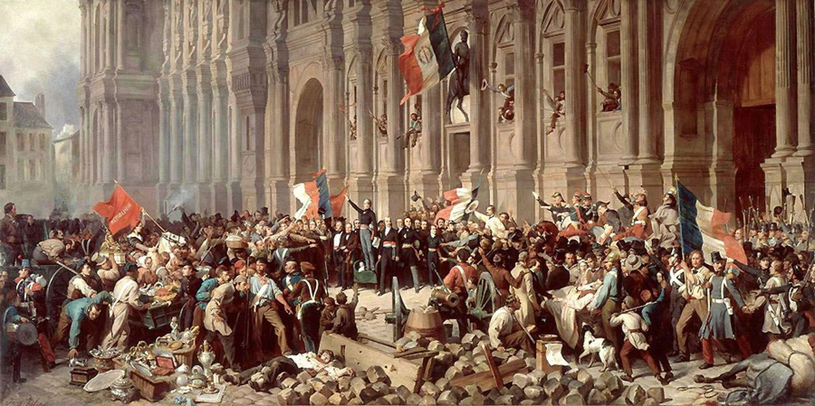

France was the most advanced country in Europe with a large population and much foreign trade. France was also the center of Enlightenment.

The cons of France was bad harvest, high prices, high taxes, and many Enlightenment ideas by Locke, Rousseau, and Voltaire.

"120 pieces of artillery, 20 generals, and more than 30,000 men taken prisoner- such are the results of this day which will forever be famous... And it will be enough for you to say, "I was at Austerlitz," to hear the reply: "There is a brave man!"

- Napoleon

* **Old Regime**: In the 1700's, the social and political system of France.
* **Estates**: A system divided into 3 social classes.
* *First estate* was the Roman Catholic Church who owned 10% of the land in France . The *Second Estate* were the rich nobles who owned 20% of land. Then the *Third Estate* who owned 97% of the land that belonged to the bourgeoisie (middle class), urban workers, and peasants.
* **Louis XVI & Marie Antoinette:** France's government went into debt because of their extravagant spending.
* **Estates-General**: An assembly of representatives from all three estates.
* **National Assembly:** Third Estate who pass laws and reforms in the name of French People.
* **Tennis Court Oath:** The Third Estate went into a tennis court to pledge until to find a new constitution.
* **Great Fear:** A wave of senseless panic throughout France.

## Revolution Brings Reform and Terror

Peasants, nobles, and officers of the Church in France experienced the Great Fear. Peasants went mad towards the upper class. They attacked and destroyed the manor houses.

## Terms & names to know

* **Legislative Assembly:** This body had the power to create laws and to approve or reject declarations of war, but the king still held the executive power to enforce laws.
* **Émigrés:** Nobles and others who had fled France, hoped to undo the revolution and restore the Old Regime.
* **Sans-Culottes:** Parisian workers and small shop keepers wanted to bring eve greater changes to France, "those without knee breeches", they wore regular trousers. Gave power to the streets of France.
* **Jacobins**: Club members involved in governmental changes in September 1792 of a radical political organization.
* **Guillotine:** An efficient, humane, and quick machine to behead someone painlessly.
* **Maximilien Robespierre:** Jacobin Leader, in 1793 he became leader of the committee of Public Safety.
* **Reign Of Terror:** From 1793-1794, Robespierre ruled France nearly as a dictator and thousands of political figures and ordinary citizens were executed.

## Terms & names to know

Page 2

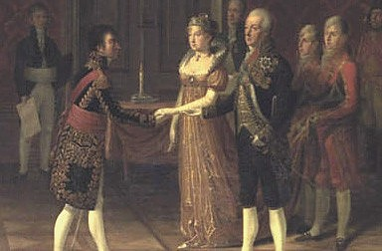

Napoleon always feared his empire collapsing. He needed a son to continue the heir, but his wife Josephine couldn't do that for him, so he married Marie Louise which he had to form an alliance with the Austrian royal family. Napoleon desired more power which was a downfall.

### Napoleon's Empire Collapses

* **Coup D'état:** A sudden seizure of power, "blow the state".
* **Plebiscite:** Vote of the people who was held to approve a new constitution.
* **Lycees:** Government-run public schools.
* **Concordat:** An agreement.
* **Napoleonic Code:** Napoleon's greatest work, a comprehensive system of laws. This gave the country a uniform set of laws and eliminated many injustices.
* **Battle of Trafalgar:** The one major battle Napoleon lost. This battle was at the southwest coast of Spain, The British commander, Horatio Nelson, was at warfare on sea, as of Napoleon on land.

### Terms & names to know

As a short man, he made a huge impact in history. Napoleon was one of the greatest military geniuses. From 1795 to 1799, he was an officer in the French Army to the master of France. He was born in 1769 on a Mediterranean island of Corsica. He has been in military school most of his life and when he finished school he became a lieutenant in the artillery.

### Napoleon Forges an Empire

Page 3

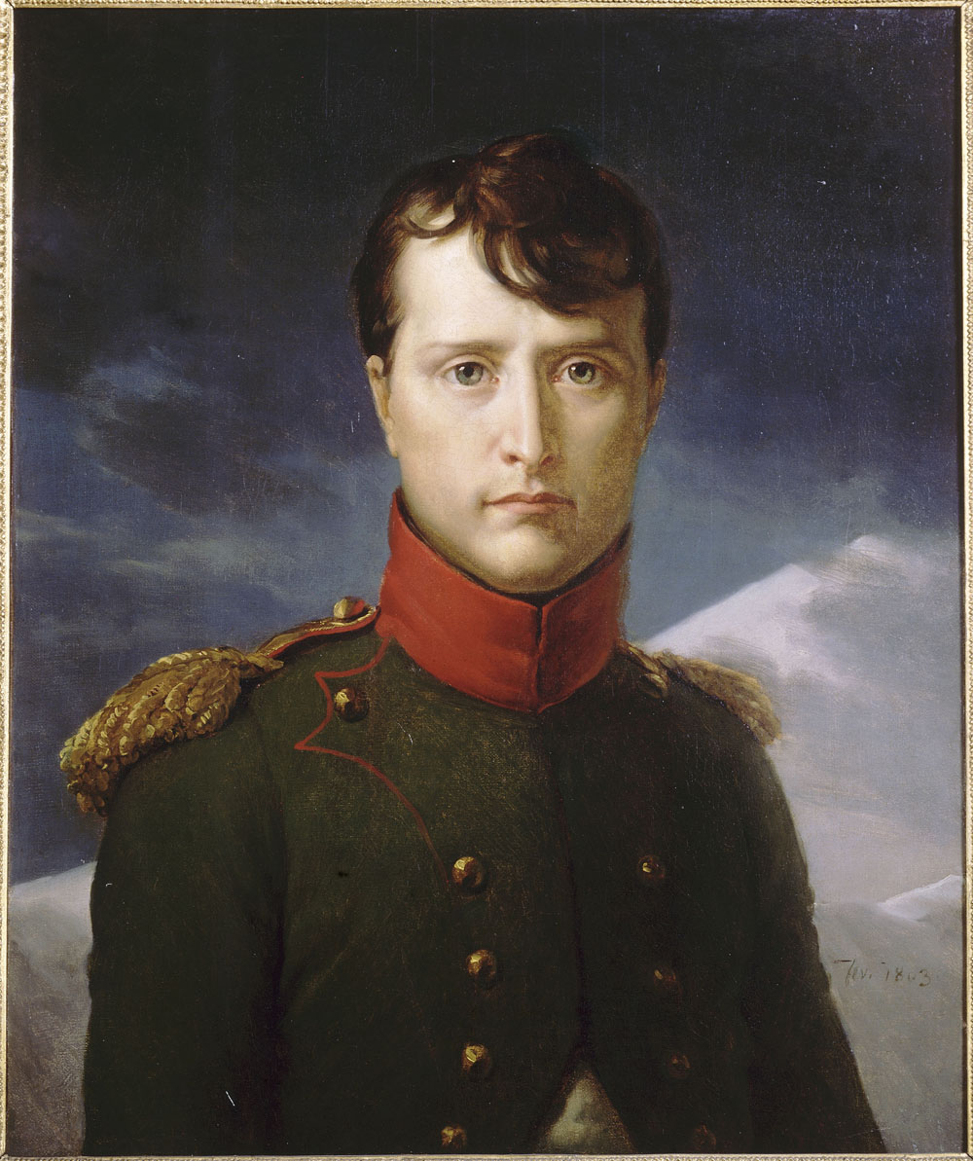

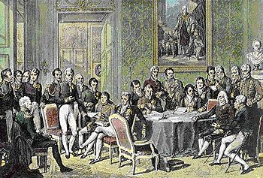

* **Congress of Vienna:** A series of meetings in Vienna were called to set up policies to achieve this goal, they went on for 8 months.
* **Klemens von Metternich:** Most influential of these representatives; was the foreign minister of Austria.
* **Balance of Power:** a political situation in which no one nation is powerful enough to pose a threat to others.
* **Legitimacy:** Agreeing that as many possible of the rulers whom Napoleon had driven from their thrones be restored to power.
* **Holy Alliance:** Pledged to base their relations with other nations on Christian principles in order to combat the forces of revolution.
* **Concert of Europe:** Ensured that nations would helped one another if any revolutions broke out.

**The Congress of Vienna**

Europeans heads of government were looking to establish long-lasting peace and stability on the continent after the defeat of Napoleon.

### Terms & names to know

* **Blockade:** Forcible closing of ports.
* **Continental System:** Prevention of all trade and communication between Great Britain and other European nations.
* **Guerillas:** member of loosely organized fighting force that makes surprise attacks on enemy troops occupying his or her country.
* **Peninsular War:** Napoleon lost 300,000 men in Spain on the Iberian Peninsula.
* **Scorched-Earth Policy:** Burning grain fields and slaughtering live stock so as to leave nothing for the enemy to eat.
* **Waterloo:** The British army, led by Duke of Wellington prepared a battle in Waterloo in Belgium. British and Prussian armies attacked the French.
* **Hundred Days:** Napoleon's last bid of power. The British shipped Napoleon to St. Helena, a remote island in the South Atlantic. He was exiled for 6 years, then died in 1821.

Terms & names to know

Page 4